Dayton Flores & Mark Sherman

ECEN 5803-401

6/26/22

Project 1 – Module 2

Lab Exercise 2.8.1. See attached ***2_8_1-digital_io_uvision6_nucleo_f401re*** for mBed BIN + Keil UVPROJX files.

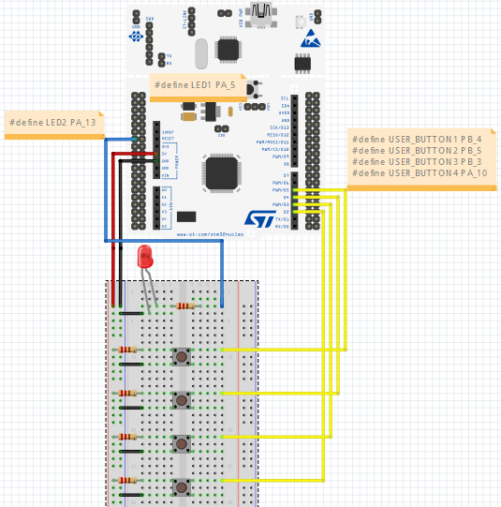

Lab Exercise 2.8.2. See attached ***2_8_2-interrupt_uvision6_nucleo_f401re*** for mBed BIN + Keil UVPROJX files.

Changing the interrupt on different signal edges changes at which point of the button push the

LEDs toggle (beginning of button push or letting go of button push)



Lab Exercise 2.9. See attached 2_9-audio_uvision6_nucleo_f401re for mBed BIN + Keil UVPROJX files. Adjusting the increment on i allows for finer tuning of each saw-tooth in the wave. For instance, the smaller the increment then the smoother the volume sounds going from minimum adjusted volume to the user’s adjusted volume.

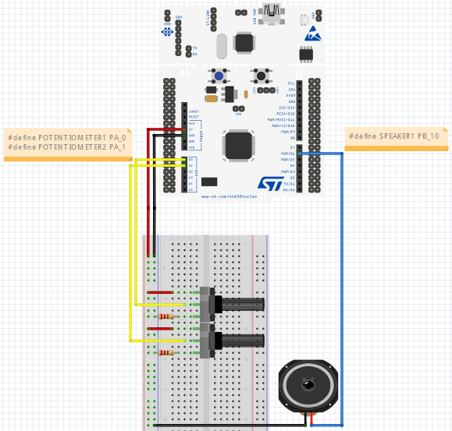

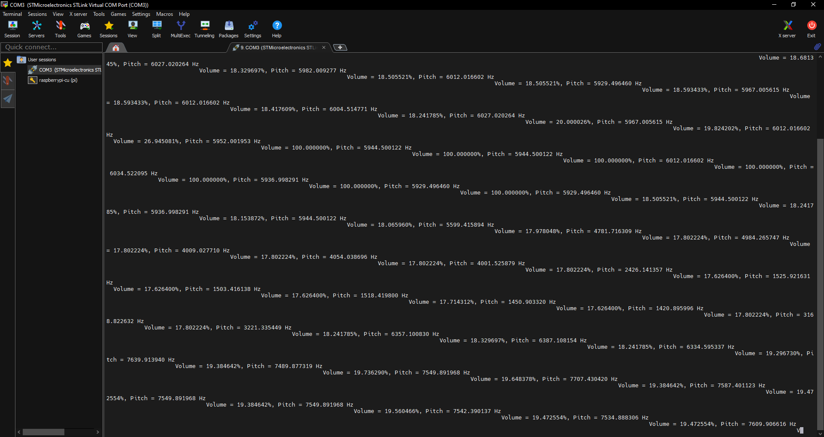

Lab Exercise 2.11. The temperature being displayed on my terminal window is ~27 degrees C. The temperature

being displayed on LCD was not able to be captured due to faulty LCD. We had Sankalp’s help in

testing code for the LCD and he confirmed our ***integration*** program was working properly but

Sankalp did not have the temperature sensor connected.

I2C:

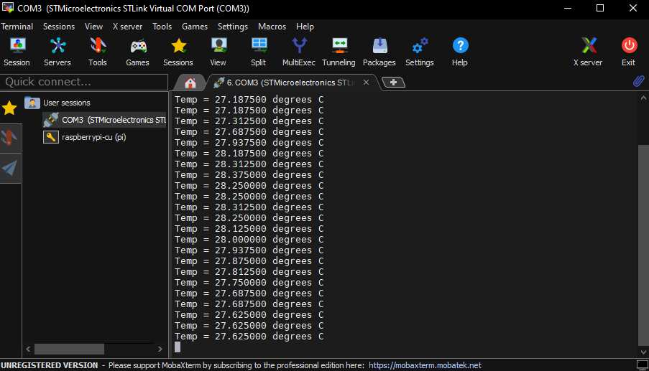

LCD:

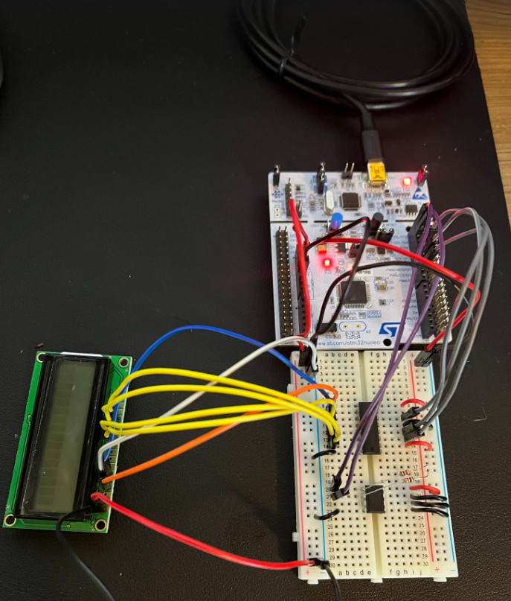

UART:

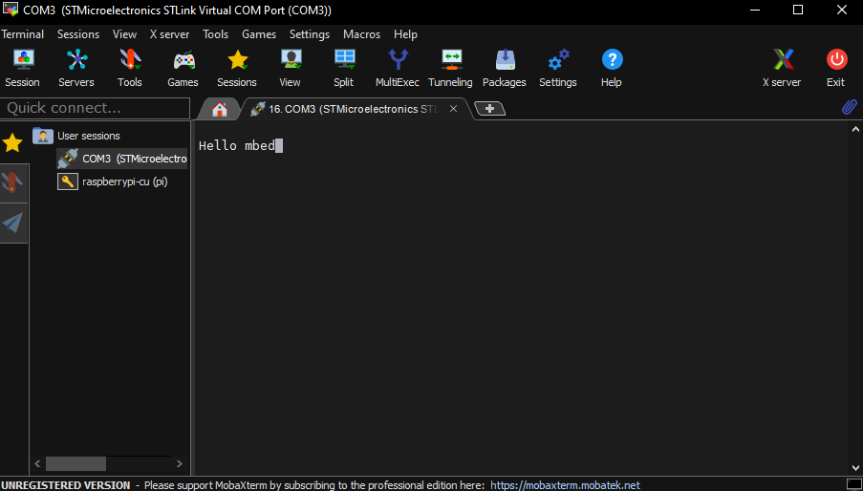

Integration:

